**DR B.R. AMBEDKAR NATIONAL INSTITUTE OF**

**TECHNOLOGY JALANDHAR,**

**PUNJAB, INDIA**



**Web Technologies Laboratory**

**CSX-330**

**Session: Jan-May 2020**

**SUBMITTED BY-**

Name – Ankit Goyal

Roll no - 17103011

Group - G-1

Branch - CSE

**SUBMITTED TO-**

Dr. Avtar Singh

Assistant Professor

CSE Department

**INDEX**

|  |  |  |  |
| --- | --- | --- | --- |
| **S.No.** | **PROGRAM NAME** | **PAGE No.** | **REMARKS** |
| 1. | Create your own Curriculum Vitae using HTML | 3-4 |  |
| 2. | Create static web pages using HTML. | 5-7 |  |
| 3. | Create web pages using MAP tag. | 8-10 |  |
| 4. | Impalement frames in HTML. | 11-13 |  |
| 5. | Create a scientific calculator using HTML and JavaScript. | 14-15 |  |
| 6. | Design UTKANSH website with real time clock. | 16-18 |  |
|  |  |  |  |
|  |  |  |  |
|  |  |  |  |
|  |  |  |  |
|  |  |  |  |
|  |  |  |  |
|  |  |  |  |
|  |  |  |  |
|  |  |  |  |
|  |  |  |  |
|  |  |  |  |
|  |  |  |  |
|  |  |  |  |
|  |  |  |  |
|  |  |  |  |
|  |  |  |  |
|  |  |  |  |
|  |  |  |  |

**Practical No.1**

**Aim: Create your own Curriculum Vitae using HTML.**

**Program:**

<!DOCTYPE html>

<html lang="en">

<head>

<title>CV</title>

</head>

<body>

<h1><center>Curriculum Vitae</center></h1>

<h2>Personal Details:</h2>

<p>

<font size="5">

<img src="my image.jpg" alt="My Photo" align="right" height="300">

Name : Ankit Goyal </br>

Address : Boys hostel 4,NIT jalandhar</br>

Contact : 8104XXXXXX

</font>

</p>

<h2>Objective:</h2>

<p>

<font size="5">

My objective is to secure a place in a firm where I can learn new skills, helpful in development of the firm.

</font>

</p>

<h2>Educational Qualifications:</h2>

<font size="5">

<table border="1" width="50%" >

<tr>

<th>Course</th>

<th>Institute</th>

<th>Year</th>

<th>%</th>

</tr>

<tr align="center">

<td>B.Tech</td>

<td>NIT JALANDHAR</td>

<td>2017</td>

<td>8.39</td>

</tr>

<tr align="center">

<td>12th</td>

<td>Navjeevan School Sikar</td>

<td>2016</td>

<td>96.00</td>

</tr>

<tr align="center">

<td>10th</td>

<td>AVM School Bari</td>

<td>2014</td>

<td>90.83</td>

</tr>

</table>

</font>

</body>

</html>

**Output:**

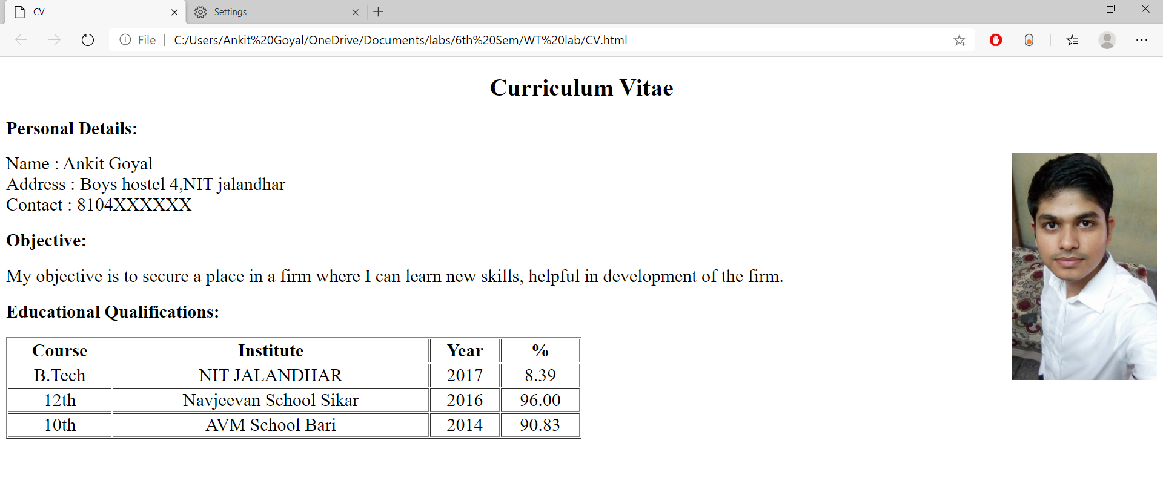

**Practical No.2**

**Aim: Create static web pages using HTML.**

**Program:**

1. **Crackers.html:**

<!DOCTYPE html>

<html lang="en">

<title>crackers</title>

<body>

<h1 style="font-size: 40px;">Crackers:</h1>

<p style="font-size: 25px;">A firecracker (cracker, noise maker, banger,[1]) is a small explosivedevice primarily designed to produce a large amount of noise, especially in the form of a loud bang; any visual effect is incidental to this goal.</p>

<img src="girl.jpg", style='margin-left :200px', width="300px"><br><br>

<a style="margin-left:80px ;font-size:40px ; color:green; " href="file:///C:/Users/Ankit%20Goyal/OneDrive/Documents/labs/6th%20Sem/WT%20lab/advantages%20of%20crackers.html">Advantages </a>

<a style="margin-left:160px ;font-size:40px ; color: red; " href="file:///C:/Users/Ankit%20Goyal/OneDrive/Documents/labs/6th%20Sem/WT%20lab/disadvantages%20of%20crackers.html">Disadvantages </a>

</body>

</html>

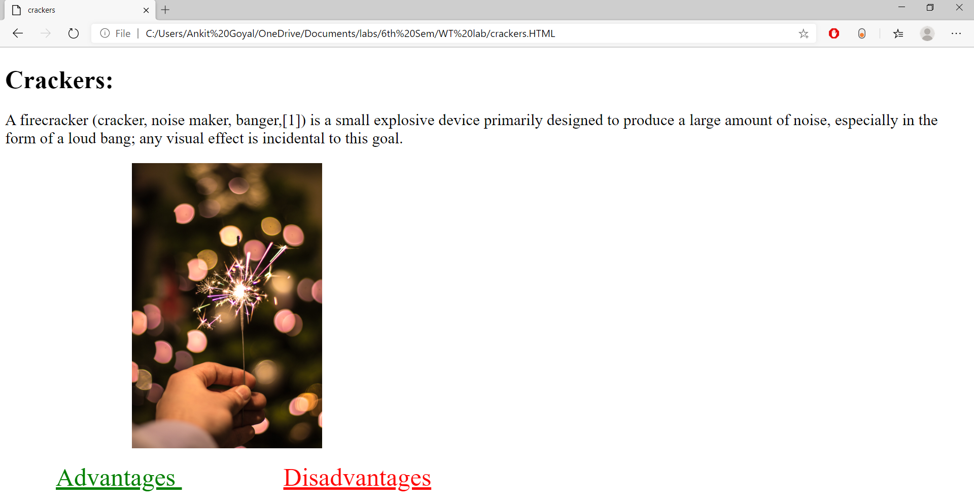

1. **Advantages of Crackers.html**

<!DOCTYPE html>

<html>

<title>Advantages</title>

<body>

<p style="text-align: center; color: green;font-size: 40px;">Advantage</p>

<h2>1. Fun like never before</h2>

<p style="font-size: 25px;">Diwali is basically so much famous and awaited because of the crackers, Kids and people waitall year long for just this one day to burn crackers and enjoy their heart out. </p>

<h2>2. It drives technological developments</h2>

<p style="font-size: 25px;">It is a lesser known fact that many of the weapons used by our defense forces are manufactured by Indian fireworks industries. Also, it is only because of the crackers that we were able to design missiles and rocketsthat can conquer the space today.</p>

<h2>3. It boosts up the economy</h2>

<p style="font-size: 25px;">Crackers is a huge industry which is for over Rs. 1000 crores. It directly employs more than 40,000 people that is it contributes to the livelihood of about 6-7 lakh people.</p>

<a style="margin-left: 600px; font-size: 35px;" href="file:///C:/Users/Ankit%20Goyal/OneDrive/Documents/labs/6th%20Sem/WT%20lab/crackers.HTML"> Click here to go back</a>

</body>

</html>

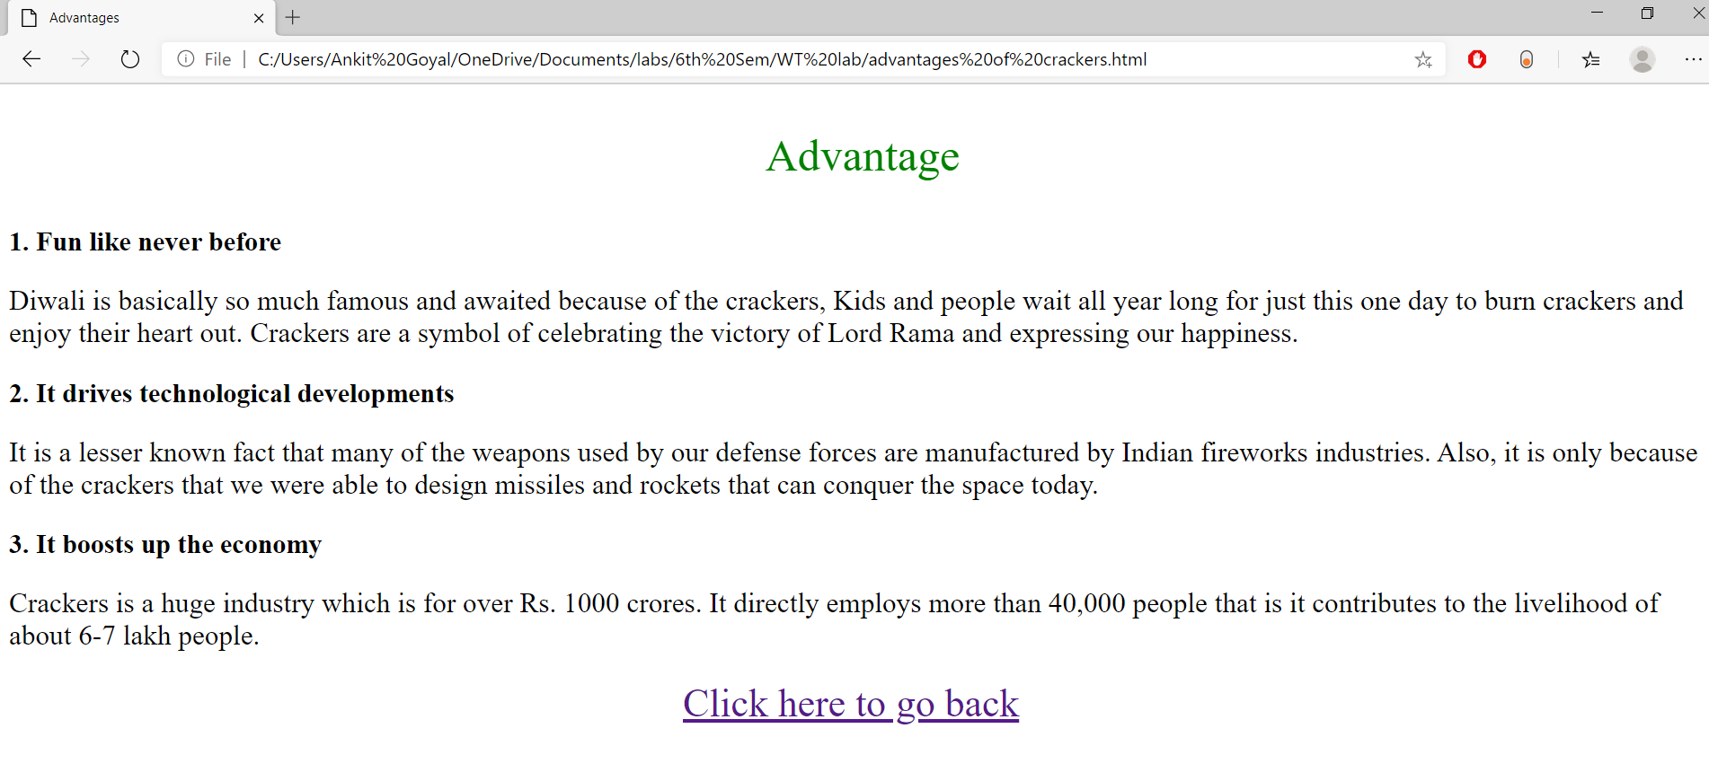

1. **Disadvantages of Crackers.html**

<!DOCTYPE html>

<html>

<title>Disadvantages</title>

<body>

<p style="text-align: center; color: red;font-size: 40px;">Disadvantage</p>

<h2>1. Air Pollution</h2>

<p style="font-size: 25px;">The most significant demerit of fireworks is the pollution that it causes in the areawhere it is done excessively. Also, the crackers emit carbon dioxide which is a greenhouse gas thereby alarming the global warming effects. </p>

<h2>2. Garbage</h2>

<p style="font-size: 25px;">The garbage of the crackers which is left over after the enjoyment is a major problem to be considered. These chemical wastes can do a lot more damage than we can even imagine. If accidentally inhaled, can even cause death.</p>

<h2>3. Smog</h2>

<p style="font-size: 25px;">The air we breathe no longer remains pure. Diwali crackers are a major cause for the smog suspended in the atmosphere. There is low visibility which can be a cause for many major road accidents. </p>

<a style="margin-left: 600px; font-size: 35px;" href="file:///C:/Users/Ankit%20Goyal/OneDrive/Documents/labs/6th%20Sem/WT%20lab/crackers.HTML"> Click here to go back</a>

</body>

</html>

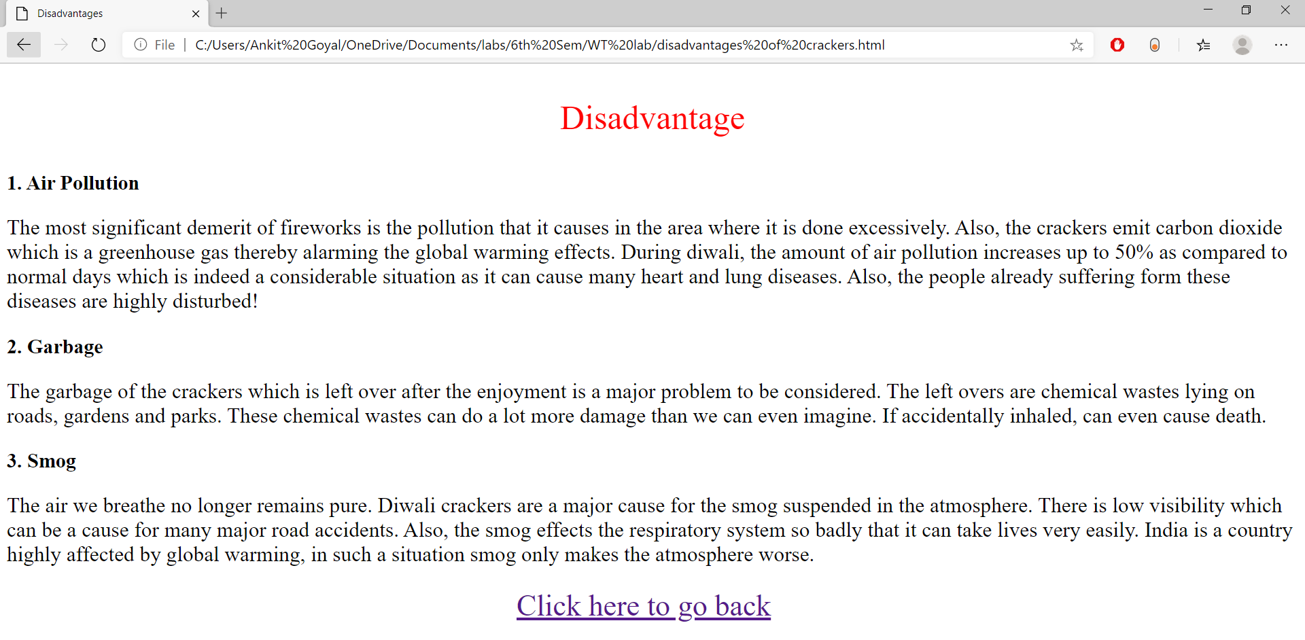

**Practical No.3**

**Aim: Create web pages using MAP tag.**

**Program:**

1. **India.html**

<!DOCTYPE html>

<html lang="en">

<title>India Map</title>

<body>

<h1>India:</h1>

<img style="margin: 40px;" src="images/india-political-map.gif" height="600" usemap="#indiaMap">

<map name="indiaMap">

<area shape="circle" coords="90,200,55" href="file:///C:/Users/Ankit%20Goyal/OneDrive/Documents/labs/6th%20Sem/WT%20lab/rajasthan.html">

<area shape="circle" coords="380,0,160" href="file:///C:/Users/Ankit%20Goyal/OneDrive/Documents/labs/6th%20Sem/WT%20lab/china.html">

</map>

</body>

</html>

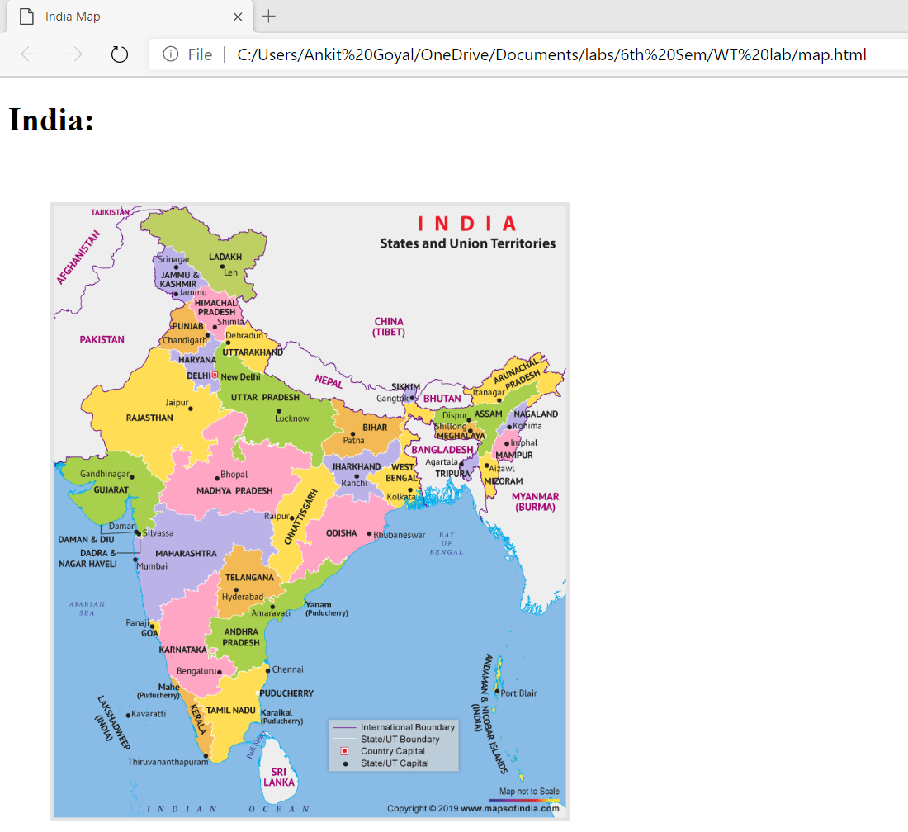

1. **Rajasthan.html**

<!DOCTYPE html>

<html lang="en">

<head>

<title>Rajasthan</title>

</head>

<body>

<h1>Rajasthan (Largest State):</h1>

<img style="margin: 20px;" src="images/rajasthan_map.gif" height="600">

</body>

</html>

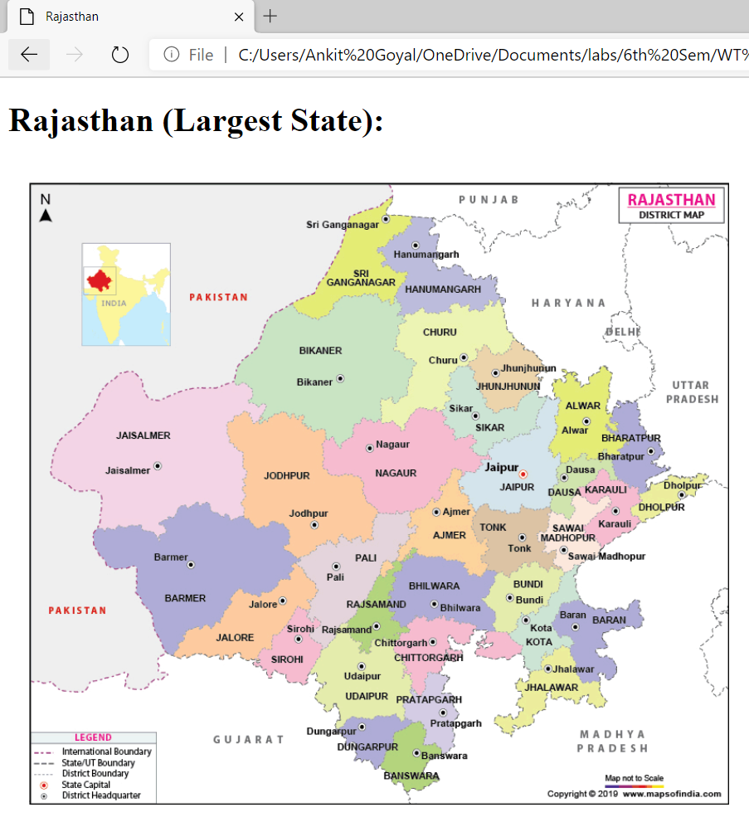

1. **China.html**

<!DOCTYPE html>

<html lang="en">

<head>

<title>China</title>

</head>

<body>

<h1>China (Bad Neighbour):</h1>

<img style="margin: 20px;" src="images/map-of-china.jpg" height="600">

</body>

</html>

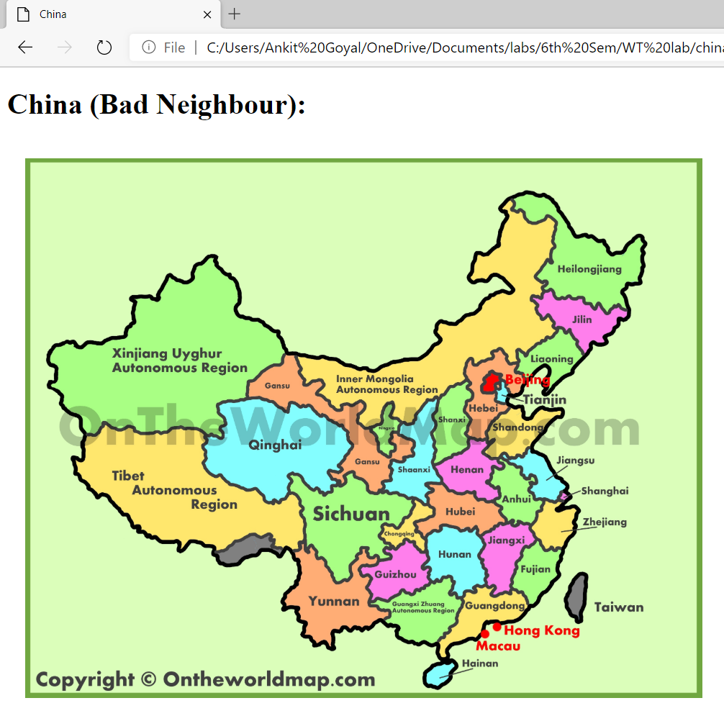

**Practical No.4**

**Aim: Impalement frames in HTML.**

**Program:**

* **Frames.html**

<!DOCTYPE html>

<html>

<head>

<title>Frames</title>

</head>

<iframe src="forms.html" width="500" height="700"></iframe>

<iframe width="500" height="700" src="https://www.youtube.com/embed/M7-FFtYSCGg" frameborder="0" allow="accelerometer; autoplay; encrypted-media; gyroscope; " allowfullscreen></iframe>

<iframe src="drag and drop.html" width="490" height="700"></iframe>

</html>

* **Forms.html**

<!DOCTYPE html>

<html lang="en">

<head>

<title>Forms</title>

<style>

label{

margin-right: 5px;

font-weight: bold;

}

legend{

font-size: 20px;

font-weight: bold;

}

</style>

</head>

<body style="margin-left: 30px;">

<a href="home page.html">Go Back</a>

<h1 style="text-align: center;">Registration From</h1>

<form target="_self" method="GET">

<fieldset>

<legend>Personal Details</legend>

<label for="first_name">First Name</label>

<input type="text" id="first_name" style="margin-right: 30px;">

<label for="last_name">Last Name</label>

<input type="text" id="last_name"><br><br>

<b>Gender<br></b>

<input type="radio" name="Gender"> Male

<input type="radio" name="Gender" >Female<br><br>

<label for="dob">Date of Birth</label>

<input type="date" id="dob">

</fieldset><br>

<fieldset>

<legend>Contact Details</legend>

<label for="phone">Phone No</label>

<input type="number" id="phone"><br><br>

<label for="mail">Email</label>

<input type="email" id="mail"><br><br>

</fieldset><br>

<fieldset>

<legend>Adderss</legend>

<label for="street">Street</label>

<input type="text" id="street" style="margin-right: 30px;">

<label for="city">City</label>

<input type="text" id="city"><br><br>

<label for="state">State</label>

<input type="text" id="state"><br><br>

</fieldset><br>

<div style="text-align: center;">

<input type="reset" value="Reset" style="font-size: 20px; margin-right: 20px;">

<input type="submit" value="Submit" style="font-size: 20px;">

</div>

</form>

</body>

</html>

* **drag and drop.html**

<!DOCTYPE HTML>

<html>

<head>

<script>

function allowDrop(ev) {

ev.preventDefault();

}

function drag(ev) {

ev.dataTransfer.setData("text", ev.target.id);

}

function drop(ev) {

ev.preventDefault();

var data = ev.dataTransfer.getData("text");

ev.target.appendChild(document.getElementById(data));

}

</script>

</head>

<body style="margin-left: 20px;">

<a href="home page.html">Go Back</a>

<h1 style="text-align: center;">Drag and Drop</h1>

<div id="div1" ondrop="drop(event)" ondragover="allowDrop(event)" style="width: 300px;height: 300px;border: 1px solid;"></div><br>

<img id="drag1" src="images/girl.jpg" draggable="true" ondragstart="drag(event)" width="280" height="280">

</body>

</html>

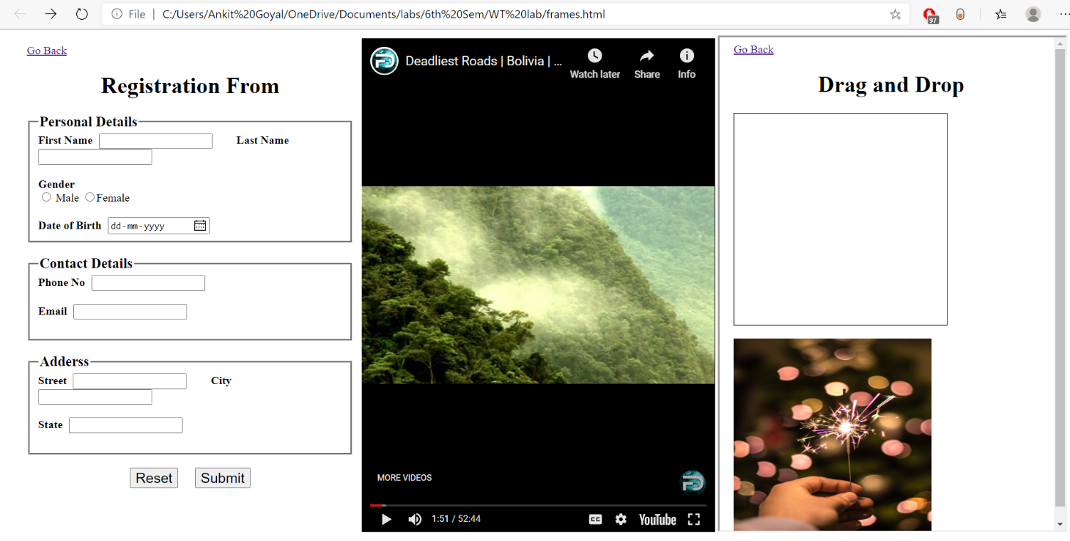

**Practical No.5**

**Aim: Create a scientific calculator using HTML and JavaScript.**

**Program:**

<!DOCTYPE html>

<html lang="en">

<head>

<title>Calculator</title>

<style>

body{

background-color: rgba(255, 166, 0, 0.158);

}

button {

margin: 3px;

background-color: rgba(51, 50, 49, 0.856);

width: 60px;

height: 40px;

font-size: 30px;

color:orange;

}

</style>

<script>

function cal(symbol)

{

var a=Number(document.getElementById("number_a").value);

a='('+a+symbol;

calculate(a);

}

function calculate(a)

{

var b=Number(document.getElementById("number_b").value);

a=a+b+')';

document.getElementById("ans").innerHTML="Answer is "+eval(a);

}

</script>

</head>

<body>

<a href="home page.html">Go Back</a><br><br>

<h2><i>Scientific Calculator</i></h2>

<p style="font-size: 12px;margin-left: 15px;">*If only one operand is required then use Second Number.</p>

<label for="number_a" style="margin: 20px; padding-right: 17px;">First Number</label>

<input type="text" id="number_a" value="0"><br><br>

<label for="number_b" style="margin: 20px;" >Second Number</label>

<input type="text" id="number_b" value="0"><br>

<p style="font-size: 10px;"></p>

<table style="background-color:rgba(192, 175, 120, 0.781);margin: 25px;">

<tr >

<td><button type="button" onclick="cal('+')">+</button></td>

<td><button type="button" onclick="cal('-')">-</button></td>

<td><button type="button" onclick="cal('*')">*</button></td>

<td><button type="button" onclick="cal('/')">/</button></td>

</tr>

<tr>

<td><button type="button" onclick="calculate('Math.sin(')" >sin</button></td>

<td><button type="button" onclick="calculate('Math.cos(')" >cos</button></td>

<td><button type="button" onclick="calculate('Math.tan(')" >tan</button></td>

<td><button type="button" onclick="cal('%')" >%</button></td>

</tr>

<tr>

<td><button type="button" onclick="calculate('Math.exp(')">exp</button></td>

<td><button type="button" onclick="calculate('Math.sqrt(')">sqrt</button></td>

<td><button type="button" onclick="calculate('Math.log(')">log</button></td>

<td><button type="button" onclick="cal('**')">^</button></td>

</tr>

</table>

<p id="ans" style="font-size: 20px;">Answer will be shown here.</p>

</body>

</html>

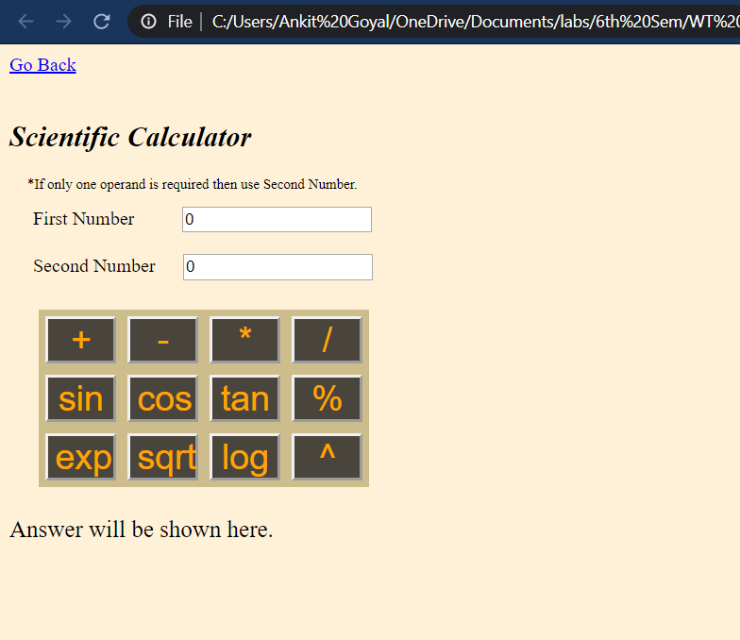

**Practical No.6**

**Aim: Design UTKANSH website with real time clock.**

**Program:**

<!DOCTYPE html>

<html lang="en">

<head>

<title>Utkansh</title>

<link rel="stylesheet" href="utkansh.css">

</head>

<body>

<a href="home page.html">Back</a>

<div class="header">

<p class="subheading">NITJ PRESENTS</p>

<p class="mainheading">Utkansh 2k20</p>

<!-- <p class="clock" onload="showtime()"></p> -->

<div id="DigitalCLOCK" class="clock" onload="showTime()"></div>

<button type="button">Register</button>

<button type="button">Login</button>

</div>

<script src="utkansh20.js" ></script>

</body>

</html>

**Utkansh.css-**

.header{

/* background-color: rgb(158, 161, 131); */

background-color: rgba(248, 164, 8, 0.24);

height: 100%;

text-align: center;

margin: 0px;

}

.subheading{

font-size: 30px;

font-style: italic;

padding-top: 30px;

/* color: azure; */

/* margin: 0px; */

}

.mainheading{

font-size: 150px;

margin: 0px;

color: rgba(218, 34, 34, 0.993);

font-family: 'Gill Sans', 'Gill Sans MT', Calibri, 'Trebuchet MS', sans-serif;

}

.clock{

color: rgb(0, 132, 255);

padding-top: 20px;

font-size: 50px;

margin: 100px;

}

button{

background-color: rgba(255, 140, 0, 0.644);

border: 0ch;

border-radius: 5px;

padding: 5px 16px 5px 16px;

/* margin: 50px; */

font-size: 30px;

margin-left: 10px;

font-family: Cambria, Cochin, Georgia, Times, 'Times New Roman', serif;

}

html,body{

height: 100%;

margin: 0px;

}

**Utkansh20.js-**

function showTime(){

var date = new Date();

var h = date.getHours();

var m = date.getMinutes();

var s = date.getSeconds();

var session = "AM";

if(h == 0){

h = 12;

}

if(h > 12){

h = h - 12;

session = "PM";

}

h = (h < 10) ? "0" + h : h;

m = (m < 10) ? "0" + m : m;

s = (s < 10) ? "0" + s : s;

var time = h + ":" + m + ":" + s + " " + session;

document.getElementById("DigitalCLOCK").innerText = time;

document.getElementById("DigitalCLOCK").textContent = time;

setTimeout(showTime, 1000);

}

showTime();

**Output:**

